1. Study of Generation & Reception of BPSK. kit
2 Study of Generation & Reception of BFSK kit
3 : Study of Generation & Detection of baseband signal using Matched Filter matlab code kit not available
Code :
clc; clear;

% Parameters
N = 10; % Number of bits
fs = 100; % Samples per bit
bits = randi([0 1], 1, N); % Random bits
nrz = 2*bits - 1; % NRZ: 0→-1, 1→+1

% Pulse shaping (rectangular pulse)
pulse = ones(1, fs);
tx = kron(nrz, pulse); % Transmitted signal

% Add noise
snr = 10; % SNR in dB
P = mean(tx.^2); % Signal power
noise = sqrt(P/10^(snr/10)) * randn(1, length(tx));
rx = tx + noise; % Received signal

% Matched filter (same as pulse shape)
mf = fliplr(pulse);
y = conv(rx, mf, 'same');

% Sample at bit centers
samples = y(fs/2:fs:end);
detected = samples > 0;

% Display results
disp('Transmitted bits:');
disp(bits);
disp('Detected bits:');
disp(detected);

% BER
ber = sum(bits ~= detected)/N;
disp(['BER: ', num2str(ber)]);
OUTPUT:
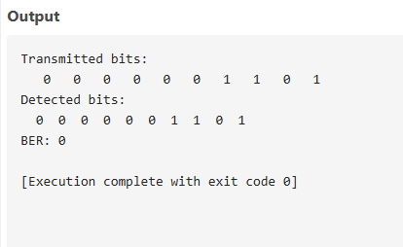
4. Study of Generation & Reception of DSSS. KIT
5 Simulation of Random Process. Matlab code
CODE:
A = 1; % Amplitude
f = 5; % Frequency in Hz
T = 1; % Total time duration in seconds
fs = 1000; % Sampling frequency
t = 0:1/fs:T; % Time vector

N = 10; % Number of random process realizations

% Initialize matrix to hold realizations
X = zeros(N, length(t));

% Generate realizations
figure;
hold on;
for i = 1:N
phi = 2*pi*rand(); % Random phase in [0, 2*pi]
X(i, :) = A * cos(2*pi*f*t + phi);
plot(t, X(i, :)); % Plot each realization
end

title('Random Process Realizations: A cos(2πft + φ)');
xlabel('Time (s)');
ylabel('Amplitude');
grid on;
hold off;% Parameters

OUTPUT:
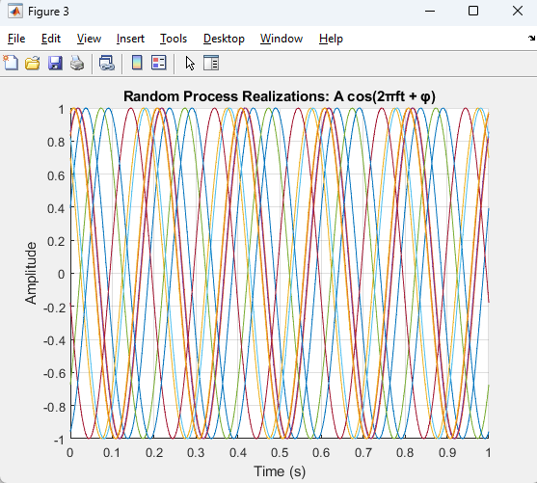
6. Simulation of performance of Binary PSK receiver in presence of noise MATLAB CODE
clc;
clear;

% Parameters
N = 1e6; % Number of bits
EbN0_dB = -4:1:10; % Eb/N0 range in dB
ber_sim = zeros(size(EbN0_dB)); % Preallocate for speed

% Generate random bits
bits = randi([0 1], 1, N);

% BPSK Modulation: 0 -> -1, 1 -> +1
symbols = 2*bits - 1;

for i = 1:length(EbN0_dB)
% Convert Eb/N0 from dB to linear
EbN0 = 10^(EbN0_dB(i)/10);

% Noise standard deviation (since Es = 1 for BPSK)
noise_std = sqrt(1 / (2 * EbN0));

% Generate AWGN
noise = noise_std * randn(1, N);

% Transmit over AWGN channel
received = symbols + noise;

% Receiver: Hard decision decoding
detected_bits = received > 0;

% Count bit errors
ber_sim(i) = sum(bits ~= detected_bits) / N;
end

% Theoretical BER for BPSK in AWGN
EbN0_lin = 10.^(EbN0_dB / 10);
ber_theory = qfunc(sqrt(2 * EbN0_lin));

% Plotting
figure;
semilogy(EbN0_dB, ber_sim, 'bo-', 'LineWidth', 2);
hold on;
semilogy(EbN0_dB, ber_theory, 'r--', 'LineWidth', 2);
grid on;
xlabel('E_b/N_0 (dB)');
ylabel('Bit Error Rate (BER)');
title('BER Performance of BPSK over AWGN Channel');
legend('Simulated BER', 'Theoretical BER');
axis([-4 10 1e-6 1]);

OUTPUT:
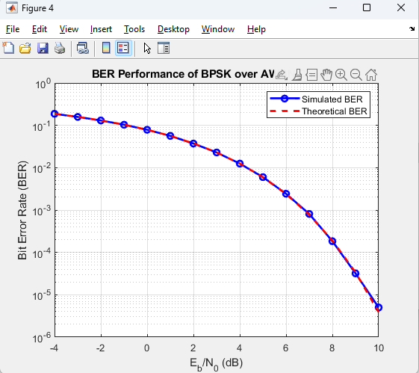
7. Simulation study of various Entropies and mutual information in a
communication system MATLAB CODE
>> clc;
clear;

% Define Channel Transition Matrix P(Y|X)
% Example: Simple 2x2 Channel
P_Y_given_X = [0.8 0.2; % P(Y=1|X=1), P(Y=2|X=1)
0.1 0.9]; % P(Y=1|X=2), P(Y=2|X=2)

% Define Input Distribution P(X)
P_X = [0.6, 0.4]; % Probability distribution for X = [X1, X2]

% Number of input and output symbols
[num_outputs, num_inputs] = size(P_Y_given_X);

% Compute Joint Distribution P(X, Y)
P_XY = zeros(num_outputs, num_inputs);
for x = 1:num_inputs
for y = 1:num_outputs
P_XY(y,x) = P_X(x) * P_Y_given_X(y,x); % Joint probability P(X, Y)
end
end

% Compute Marginal Distribution of Y
P_Y = sum(P_XY, 2); % P(Y)

% Compute Entropies
% H(X) - Entropy of input distribution
H_X = -sum(P_X .* log2(P_X + eps)); % Add eps to avoid log2(0)

% H(Y) - Entropy of output distribution
H_Y = -sum(P_Y .* log2(P_Y + eps)); % Add eps to avoid log2(0)

% H(Y|X) - Conditional entropy of Y given X
H_Y_given_X = 0;
for x = 1:num_inputs
for y = 1:num_outputs
p_y_given_x = P_Y_given_X(y, x);
if p_y_given_x > 0
H_Y_given_X = H_Y_given_X - P_X(x) * p_y_given_x * log2(p_y_given_x);
end
end
end

% Mutual Information I(X;Y)
I_XY = H_X - H_Y_given_X;

% Display Results
fprintf('H(X) = %.4f bits\n', H_X);
fprintf('H(Y) = %.4f bits\n', H_Y);
fprintf('H(Y|X) = %.4f bits\n', H_Y_given_X);
fprintf('I(X;Y) = %.4f bits\n', I_XY);

OUTPUT:
